  
DICE.com Posting Procedures

Updated Dec. 2019  
Technical Connections

**Table of Contents**

Posting a New Job………………………………………………………………………….………………………pp. 1 - 4

Refreshing Active Jobs……………………………………………………….…………………………………..pp. 5 - 6

Inactivating Active Jobs………………………………………………………….……………………………….…….p. 7

Reposting Inactive Jobs.………………………………………………………….……………………………..pp. 8 - 9

**Posting a New Job**

1. Go to the following website: <https://employer.dice.com/daf/servlet/DAFctrl?op=1201>
2. Login with the following info:

un: smackinnon@tci-la.com

pw: Abcd1234!

1. Once logged in, click on “Post Jobs & Find Candidates” at the top toolbar of the webpage.
   1. Click on "Post a New Job" in the left column.  
        
      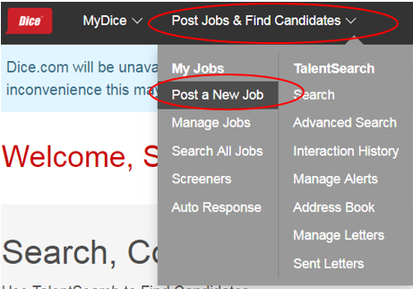

1. When entering job details, start by select the correct seat for the Primary Recruiter as follows:

[cmyers@tci-la.com](mailto:cmyers@tci-la.com) = Christine

[jcarlson@tci-la.com](mailto:jcarlson@tci-la.com) = Jen

[lbailey@tci-la.com](mailto:lbailey@tci-la.com) = Lynn

[rwolf@tci-la.com](mailto:rwolf@tci-la.com) = Russ, Bobby, Margeaux

[smackinnon@tci-la.com](mailto:smackinnon@tci-la.com) = Scott, Barbara, Mary, Garry

(continued on next page)

1. Continue by entering the job’s information as found in Bullhorn (see below images for reference):

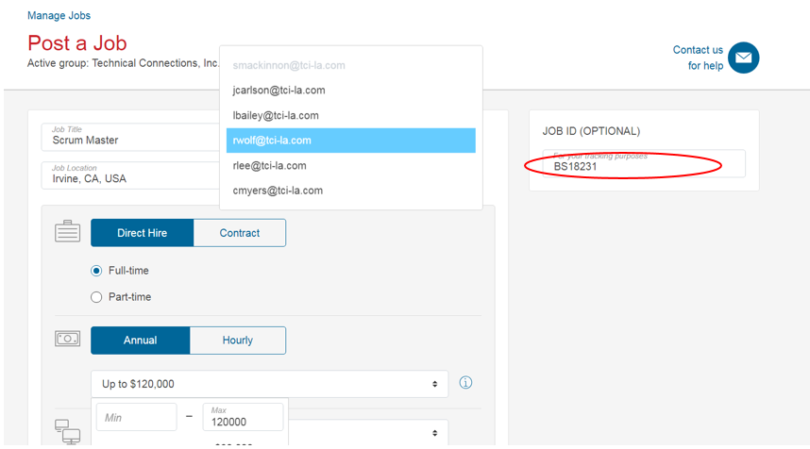

**Helpful Tips:**

* The Job ID is the Primary Recruiter’s initials and the job’s Bullhorn ID (see above image).
* For the Skills section (below), either cut and paste the keywords from the Bullhorn job order, or enter each with a comma, then click “Add”.

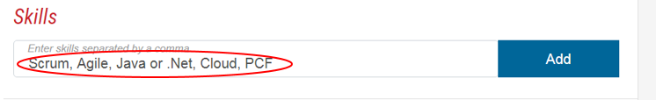  
 ^^ *Before clicking “Add”*

(continued on next page)

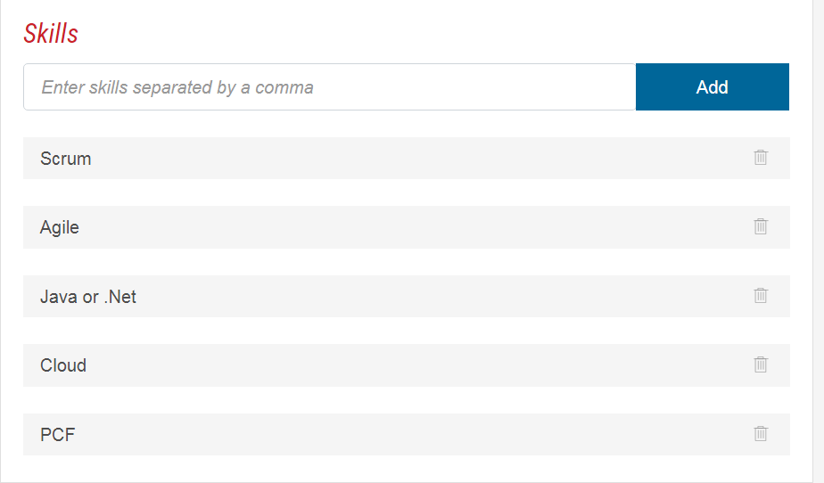

*^^ After clicking “Add”*

Also, be sure to uncheck any contact information (applications will be going directly to the Primary Recruiter - which will be seen in the image   
following the below image):

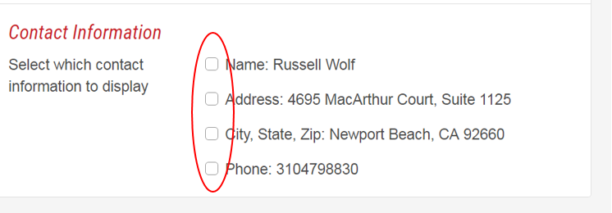

(continued on next page)

1. Enter in the Primary Recruiter’s email address to be directed, then click “Post as Active”.

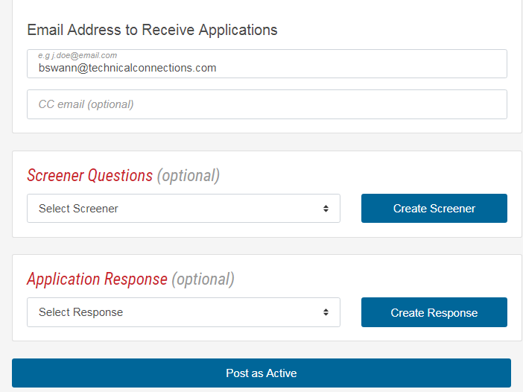

After clicking “Post as Active”, the post will go live as of the present date.

**Refreshing Active Jobs**

1. Click on “Post Jobs & Find Candidates” at the top toolbar of the webpage.
2. Click on "Manage Jobs" in the left column.

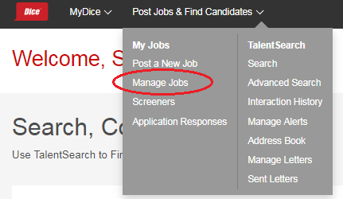

1. On the following Manage Jobs screen, click the “Select 25 jobs in view” button to select and repost **all** jobs.   
     
   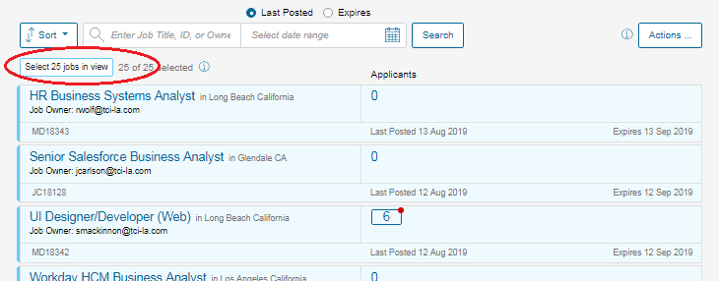

(continued on next page)

Note that you can also repost jobs **individually** by hovering the cursor over the left side of a job, then clicking to select:

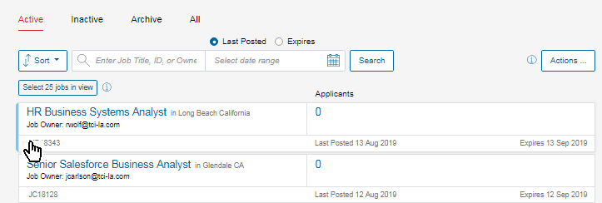

1. Once the desired jobs have been selected for reposting, click the “Actions” button on the right-hand side, and select “Repost” from   
   the dropdown menu:

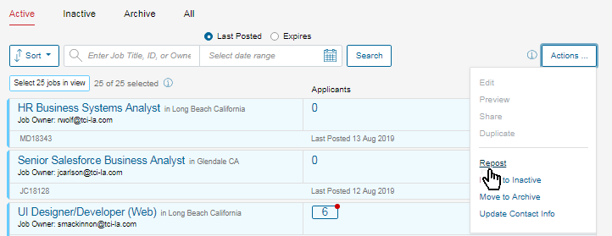

The selected jobs will then have been reposted as of the present date.

**Inactivating Active Jobs**

To inactivate an active job, hover the cursor over the left side a job, then click to select:



Perform this action to as many active jobs desired for inactivation.

Then, click the “Actions” button on the right-hand side, and select “Repost” from the dropdown menu:

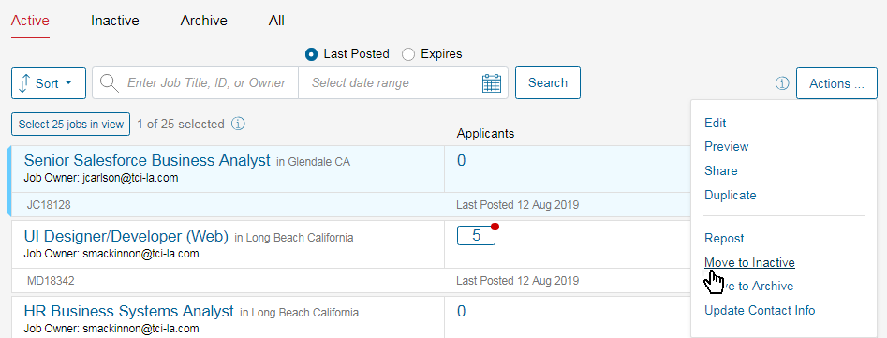

The selected jobs will have then been reposted as of the present date.

**Reposting Inactive Jobs**

*(Note: Please be sure that at least one job slot is available per desired job to repost. If all 25 job slots have been used, please follow the procedures in the above section titled “Inactivating Currently Posted Jobs”, then proceed with the following instructions.)*

On the Manage Jobs page, click the Inactive tab at the top of the jobs display:

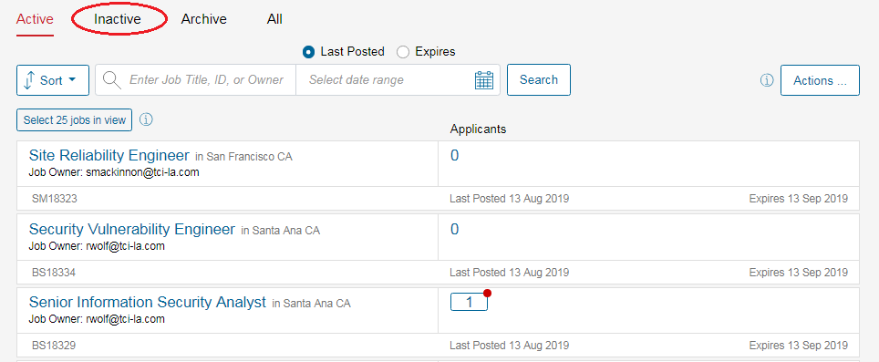

Hover the cursor over the left side a job, then click to select:

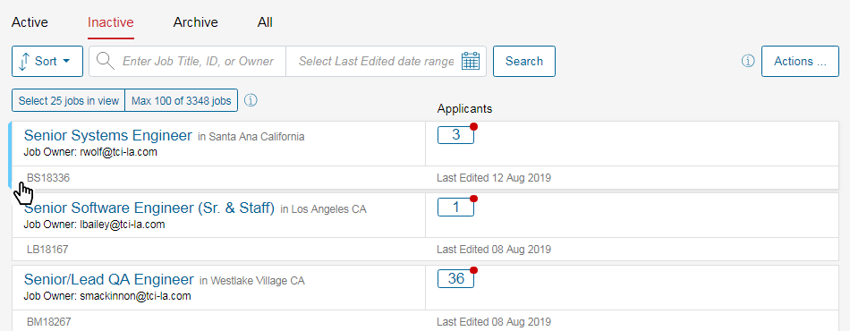

(continued on next page)

Once the desired jobs have been selected for reposting, click the “Actions” button on the right-hand side, and select “Repost” from   
the dropdown menu:

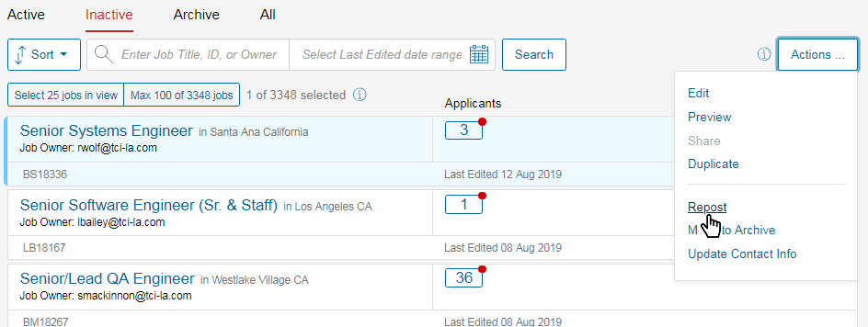

The selected jobs will then have been reposted as of the present date.